Aptify - Steps to Delete Azure Infrastructure
- Delete production resource group
- Delete the disconnected peering connection from aadds-vnet
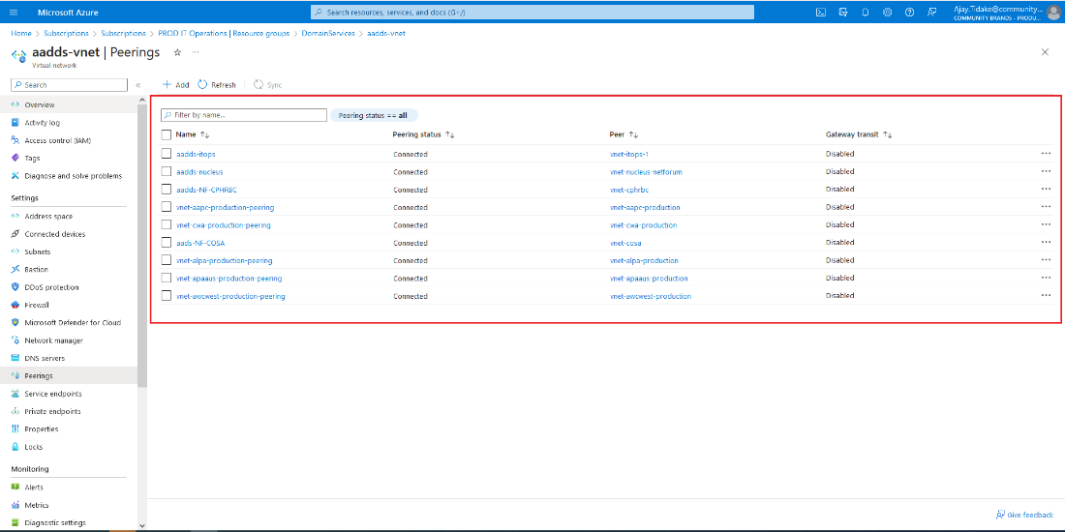
- Disable Recovery Services vault soft delete in management resource group
  - Go to the management resource group
  - Open Recovery Services vault
  - Go to the overview-click on delete
  - disable soft delete
  - scroll down- check on the box (I wish to permanently delete the vault.) then click on delete.
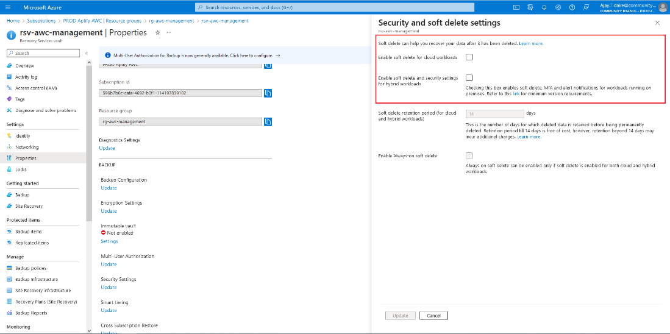
- Delete management resource group
- Go to test subscription- click on manage deleted vaults- search-subscription-Purge deleted key vault to successfully delete the key vault
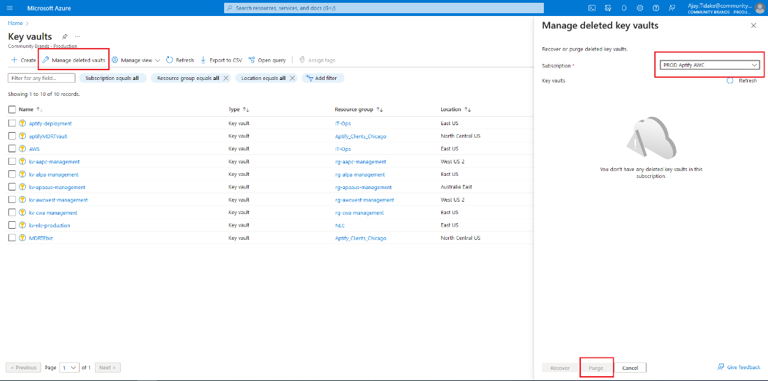
- First go PROD IT Operations- open VPN RG -click on “Virtual network gateway’ and download the VPN configuration file-(we need to login with Management VPN-VPN-virtual-network-gateway-1)
Then, Login to prod-mgmt-1 VM In the IT-ops Resource group and remove Session host and SSRS computer entries from domain controller.
Prod-mgmt-1 credentials:
ravendra.tiwari@communitybrandscloud.onmicrosoft.com
Vb<3|3c<IQ/6Aj4

Note: Prod-mgmt-1: this ad server is also used for netforum vm.
Go to active directory user and computer(OR search with- dsa.msc)- click on AptifycustomerImplements group and delete the computer name.
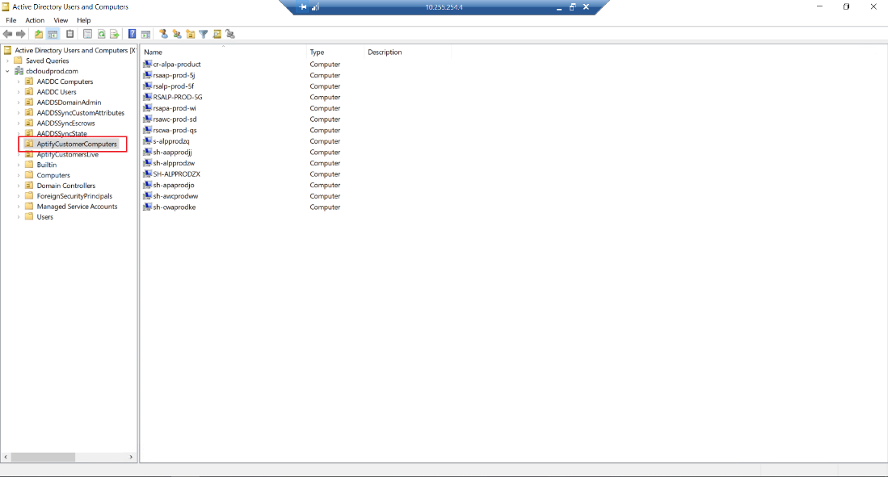
- Delete hybrid worker group: first delete worker. https://portal.azure.com/#@communitybrandscloud.onmicrosoft.com/resource/subscriptions/f719bf19-2686-4eba-8075-57329a42ea29/resourceGroups/IT-Ops/providers/Microsoft.Automation/automationAccounts/CloudOps/hybridWorkerGroups

Note: steps to access VM in the test subscription:
Go to management RG- Open the Virtual network gateway- download the configuration file and go to Azure VPN and scroll down and click on + icon and import the configuration file and connect the VPN.
We need to use management group credentials to connect the VPN.
ravendra.tiwari@communitybrandscloud.onmicrosoft.com
password- Vb<3|3c<IQ/6Aj0302

